Jordan Tower I Renovation Project
Resident Packet #1 – Introduction to the Project

What’s in this Packet?
Background of the Project
Scope of Work
Expectations
Frequently Asked Questions
Next Steps: Relocation Procedures

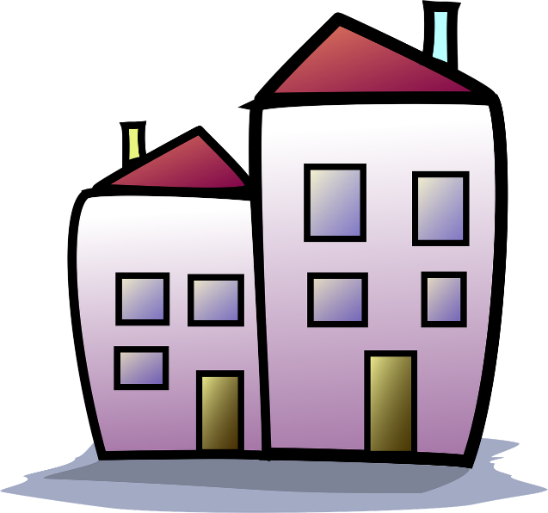
For this project to go as quickly and smoothly as possible, it is very important that you cooperate with the HRA staff and contractors.
Please follow the guidelines and instructions provided.

Red Wing Housing and Redevelopment Authority
April 2026
Background of the Project
Jordan Tower was constructed in 1974. It is a nine-story high-rise with 100 units. This is a general-occupancy building that prioritizes elderly and disabled households. The building is part of the Public Housing program funded by the U.S. Department of Housing and Urban Development (HUD).

The Publicly Owned Housing Program (POHP) was first created by the Minnesota Legislature in 2005, and there have been multiple funding rounds since then. These funds aim to rehabilitate and preserve public housing units in Minnesota. Minnesota Housing, the state’s housing finance agency, manages this program.


The Red Wing HRA submitted two applications for the 2024 POHP funding round: one for Jordan Tower I and another for the scattered family public housing sites. The Minnesota Housing Board approved the applications for Jordan Tower I for $6,275,000 and for the scattered family public housing for $1,509,700. The remaining costs of the project will be covered by the Capital Fund Program.
This Photo by Unknown Author is licensed under CC BY-SA

Since the award announcement of funding, staff have been preparing the required paperwork and gathering information to request bids for the construction project. The bids were received on March 18, 2026. Currently, staff is reviewing and analyzing these bids to select a general contractor. The next step will be to present the chosen contractor to the Red Wing HRA board for approval at the April meeting.

Scope of Work
There is a display in the Café Jordan and HRA office showing the scope of work and pictures of the current state of items being replaced. Most of the items being replaced are original to the building and are over 50 years old.

The building improvements are:
- Replacing all the domestic plumbing pipes, including water supply, waste, and vent lines.
- Replacing the domestic water heaters
- New main entry doors and secondary entry doors
- Replacing the plumbing connections in the laundry room
Unit Improvements:
- Bathroom- new toilets, sinks, faucets, vanity cabinets, shower enclosures, light fixtures, outlets, flooring, and accessories
- New kitchen sink and faucet
- New electrical panel

Expectations
The HRA will keep all residents regularly informed about the construction progress and the requirements of residents that need to be met. Notices will be posted clearly and consistently for everyone to see. The displays will be updated at each stage of the project. There will be regular meetings to review the project phases, expectations, and progress. The HRA needs residents to cooperate at every step of the project to ensure it goes as smoothly and efficiently as possible.

Frequently Asked Questions (FAQ)
Staff want to ensure everyone has clear, helpful information.
To accomplish this, we’ll create an FAQ sheet that we'll update regularly based on the questions we receive.

You can submit your questions using the question boxes located in the Café Jordan and at the entrance of the HRA office, or via email infoRWHRA@gmail.com.

Thanks for helping us maintain open and supportive communication.

Next Steps: Relocation Procedures, etc.
All residents will need to be temporarily relocated at some point during the renovation. HRA staff do not have the details yet, but once they do, there will be multiple meetings, and the next resident packet will be sent out.

There will be additional informational packets, scheduled meetings, and notices. The HRA will meet with the chosen contractor to finalize the schedules. Once the schedule is confirmed, updates about resident relocations and unit preparations will be shared with all residents.
Coming Soon
Resident Packet #2:
Construction, Relocation and Preparation of Unit

